Table1

[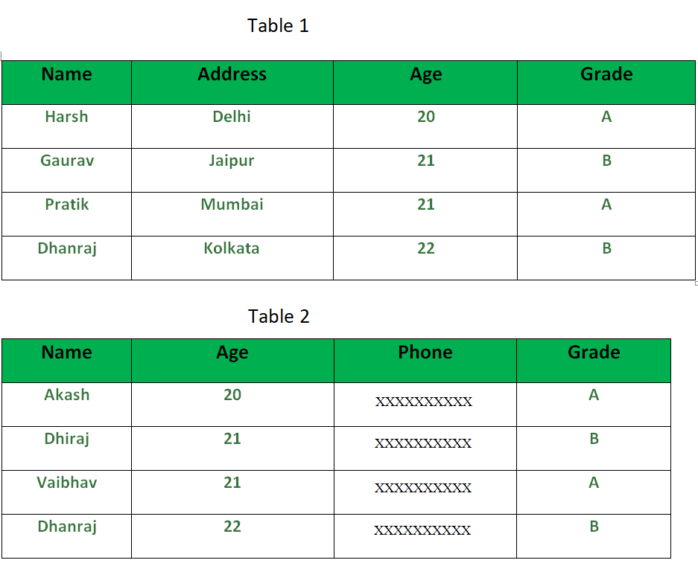](https://www.geeksforgeeks.org/wp-content/uploads/SQL_Minus_Operator_2.png)

**Queries**:

SELECT NAME, AGE , GRADE

FROM Table1

MINUS

SELECT NAME, AGE, GRADE

FROM Table2

Output:  
[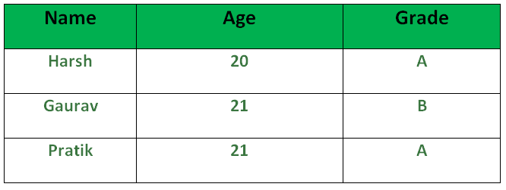](https://cdncontribute.geeksforgeeks.org/wp-content/uploads/SQL_Minus_Operator_3.png)